**Vivekanand Education Society’s Institute of Technology**

**Department of Computer Engineering**



**Subject: Social Media Analytics**

**Class: D16AD**

| **Roll No: 30** | **Name: Suhanee Kandalkar** |
| --- | --- |
| **Practical No:** | **Title:** Dashboard Design using POWER BI |
| **DOP:** | **DOS:** |
| **Grades:** | **LOs Mapped:** |
| **Signature:** |  |

**Title:** Dashboard Design using POWER BI

**BATCH B**

**DOP: 6/3/23**

**DOS: 13/3/23**

**BATCH C**

**DOP: 9/3/23**

**DOS: 16/3/23**

**BATCH A**

**DOP: 10/3/23**

**DOS: 17/3/23**

**Aim:** To Develop a dashboard based on real time social media data using PowerBI.

**Theory:**

### **Advantages of Power BI Dashboards**

Power BI is a powerful business analytics tool developed by Microsoft that enables users to visualize and analyze real-time data, including data from social media platforms. Here are several advantages of using Power BI dashboards, particularly in the context of analyzing real-time social media data:

#### **1. Real-Time Data Analysis**

* **Instant Updates:** Power BI allows you to integrate live data sources. When analyzing social media data, this feature ensures that the dashboard is updated in real time, giving you the most current insights into social media trends, user engagement, and sentiment.
* **Automated Data Refresh:** You can set automatic data refresh intervals, ensuring the data on the dashboard is always up to date without needing manual updates.

#### **2. Comprehensive Data Integration**

* **Multiple Data Sources:** Power BI enables the integration of a variety of data sources, including social media platforms (e.g., Twitter, Facebook, Instagram, LinkedIn) and other business applications. This means you can pull data from various sources and present them in a single, consolidated view on your dashboard.
* **Ease of Connection:** Power BI can connect to social media APIs, databases, and cloud storage, simplifying the integration of different data streams for analysis.

#### **3. Interactive and Visual Insights**

* **User-Friendly Visualizations:** Power BI provides a wide range of customizable charts, graphs, and visuals, such as bar charts, line graphs, heat maps, and pie charts, which make social media data easier to understand. Users can interact with these visuals to drill down into specific metrics, identify trends, and gain actionable insights.
* **Exploratory Analysis:** Users can interactively filter, drill down, and explore the data, enabling a deeper understanding of social media patterns and user behavior.

#### **4. Advanced Analytics**

* **AI-Powered Insights:** Power BI integrates AI capabilities like machine learning models, which can help in performing advanced analytics on social media data, such as predicting trends, analyzing sentiment, or categorizing social media mentions.
* **Sentiment Analysis:** Using Power BI, businesses can analyze the sentiment of social media conversations in real time, helping to gauge customer satisfaction, brand perception, or potential PR issues.

#### **5. Data Security and Compliance**

* **Row-Level Security:** Power BI allows row-level security, which ensures that only authorized users can access specific data based on their role or permission. This is critical for maintaining confidentiality when dealing with sensitive social media data.
* **Compliance with Data Regulations:** Power BI supports data governance and compliance with standards such as GDPR, making it suitable for handling social media data securely and responsibly.

#### **6. Collaboration and Sharing**

* **Real-Time Sharing:** Power BI dashboards can be shared with team members, stakeholders, or clients, and the data can be viewed in real time. This enables seamless collaboration, allowing everyone to stay on the same page with up-to-date information.
* **Embedding Dashboards:** Power BI dashboards can be embedded into other applications, websites, or even shared as reports via email, facilitating wide distribution and easy access to the data.

#### **7. Customizable and Scalable**

* **Customization:** Users can customize dashboards to display the exact metrics or KPIs that are most relevant to the organization. For example, you can focus on social media metrics like engagement rate, reach, impressions, sentiment, or hashtag performance.
* **Scalable Solutions:** Power BI is scalable, meaning it can be used by individuals, small teams, or large organizations. As your social media data grows, Power BI can handle more complex queries and larger datasets.

#### **8. Cost-Effective**

* **Affordable Licensing:** Compared to other business intelligence tools, Power BI offers an affordable pricing model, with a free version available for individual use and a relatively low cost for larger deployments. This makes it accessible for small businesses and startups looking to analyze social media data without breaking the bank.
* **Low-Cost Infrastructure:** Since Power BI is cloud-based, there is no need to invest in expensive hardware infrastructure. It’s a cost-effective solution for real-time data analysis.

#### **9. Mobile Access**

* **Mobile Compatibility:** Power BI has mobile apps for iOS and Android, allowing users to view dashboards and reports on the go. This is particularly useful for businesses that need to track social media performance in real time and make decisions on the fly.

#### **10. Time-Saving Automation**

* **Automated Alerts:** Power BI allows users to set up automated alerts, which notify you when certain social media metrics reach specified thresholds. This means that you can react to significant events (such as spikes in mentions or engagement) without constantly monitoring the data.
* **Report Generation:** Power BI allows the automation of report generation, so stakeholders can receive scheduled updates on social media performance without having to manually compile reports.

#### **11. Cloud-Based and Low Maintenance**

* **No Need for On-Premises Hardware:** Power BI is a cloud-based solution, so there’s no need for local servers, reducing the maintenance burden and costs typically associated with managing on-premises infrastructure.
* **Automatic Updates:** Since Power BI is regularly updated by Microsoft, it ensures that the latest features, security updates, and improvements are automatically available to users without requiring manual intervention.

**OUTPUT:**

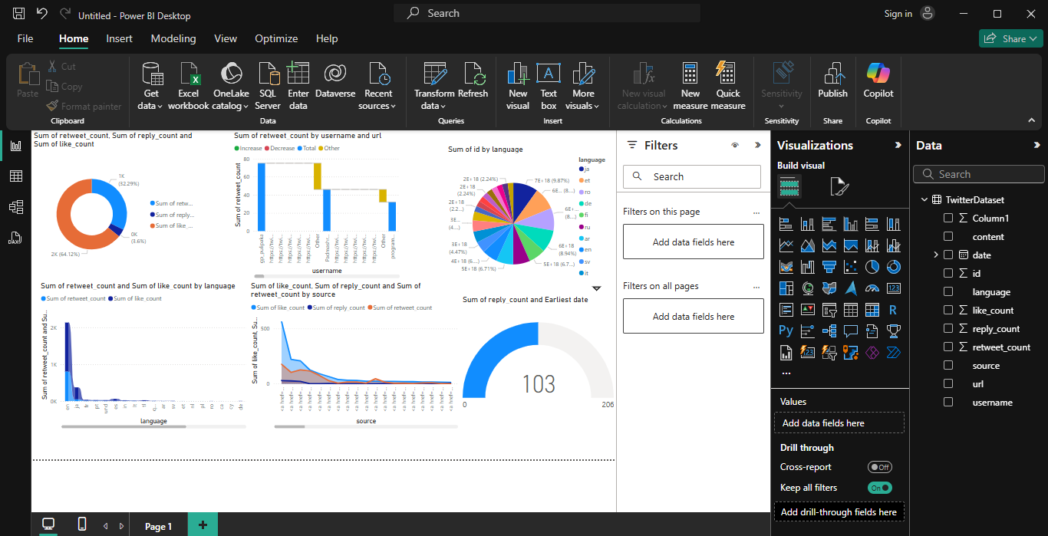

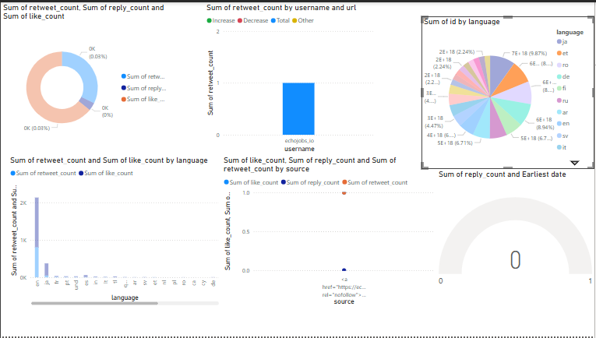

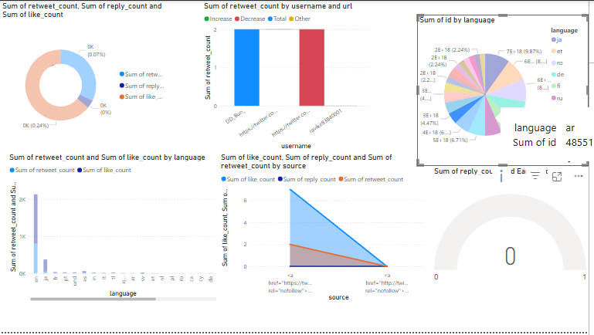

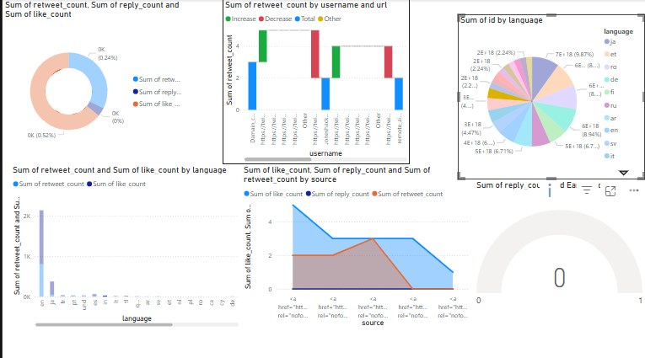

**Conclusion:**

Power BI dashboards offer a wide range of advantages when working with real-time social media data, from interactive visualizations and real-time insights to scalability and security. It provides businesses with the tools needed to make data-driven decisions based on current social media performance, ultimately enabling smarter strategies, better customer engagement, and more informed actions.